BlogScript Blog Web Application
Version 1.0
Major Project Report
BCAMP23601

BACHELOR OF COMPUTER APPLICATION


PROJECT GUIDE:  MR. AJAY SINGH SIR  MR. MAGAN SIR | SUBMITTED BY:  PANKAJ KUMAR DAS  RAHUL KUMAR SENUHAR  RAJNEESH KUMAR

COLLEGE OF COMPUTING SCIENCE & INFORMATION TECHNOLOGY
TEERTHANKER MAHAVEER UNIVERSITY, MORADABAD

DECLARATION

We hereby declare that this Project Report title BlogScript Blog Web Application submitted by us and approved by our project guide, Faculty of Engineering and Computing Sciences . Teerthanker Mahaveer University, Moradabad is a Bonafide work undertaken by us and it is not submitted to any other university or institution for the award of any degree diploma / certificate or published any time before .

Project ID:
Title | Name | Role | Signature
Student1 | Pankaj Kumar Das (TCA2301489) | Backend Developer and  Testing
Student2 | Rahul Kumar Senuhar (TCA2301558) | Frontend Developer
Student3 | Rajneesh Kumar (TCA2301573) | Documentation and Database Handle
Faculty1 | Mr. Ajay Singh | Project Presentation Guide
Faculty2 | Mr. Magan | Project Implementation Guide

Table Of Contents

- Project Title _______________________________________________ 04
- Project Domain_____________________________________________04
- Problem Statement_________________________________________ 04
- Project Description__________________________________________05
4.1 Scope of the Work______________________________________05
4.2 Project Modules_______________________________________ 05
4.3 Context Diagram_______________________________________ 06

4.4 System Architecture____________________________________ 06
- Implementation Methodology________________________________ 07
- Technologies to be Used_____________________________________ 08
6.1 Software Platform______________________________________09
6.2 Hardware Platform_____________________________________ 09
6.3 Tools Used____________________________________________09
- Advantages of This Project___________________________________ 10
- Assumptions, If Any_________________________________________11
- Future Scope and Further Enhancement of the Project_____________12
- Project Repository Location_________________________________ 12
- Definition, Acronyms, and Abbreviations______________________ 13
- Conclusion _______________________________________________ 14
- References_______________________________________________15
- Appendix_________________________________________________25
- Acknowledgement _________________________________________30

Appendix Details:
A. Data Flow Diagram (DFD)
B. Entity Relationship Diagram (ERD)
C. Use Case Diagram (UCD)
D. Data Dictionary (DD)
E. Screenshots

Project Title
This CRUD-based blog web application is designed to simplify the process of creating, managing, and sharing blog posts online in an efficient and user-friendly manner. The term CRUD stands for Create, Read, Update, and Delete, which are the four fundamental operations required to manage data in any modern web application. These operations form the core functionality of BlogScript and ensure complete control over blog content.

Project Domain
Web development using PHP and MySQL provides a powerful and reliable foundation for building dynamic and database-driven web applications. In this project, these technologies are used to develop a user-friendly blog application that allows users to efficiently manage their scripted blog content. PHP serves as the server-side scripting language responsible for application logic, while MySQL is used as the backend database to store and manage user data and blog posts.
The blog application enables users to perform all essential CRUD operations—Create, Read, Update, and Delete—on blog posts. Users can create new blog entries by providing titles, content, and other relevant details through structured forms. Once published, these blog posts can be read by users through a clean and responsive interface designed for easy navigation and readability.

Problem Statement
In today’s digital era, content creators often face difficulties in finding a minimal and distraction-free blogging platform where they can quickly publish their ideas. Many existing platforms are overloaded with advertisements, complex interfaces, and unnecessary features that divert attention away from content creation. As a result, creators struggle to focus on writing and managing their work efficiently.
Another major challenge faced by creators is content ownership and control. They require a system where their content remains secure, private, and fully manageable at any time. Creators want the freedom to edit, update, or delete their posts without restrictions, ensuring that their published content always reflects their latest ideas and perspectives.
BlogScript addresses these challenges by providing a personal and user-friendly blogging space designed specifically for creators who value simplicity and control. The platform allows users to manage their profiles, write blog posts, and modify or remove content whenever required. With an intuitive interface, BlogScript ensures that users can focus entirely on content creation without unnecessary distractions.

Project Description
To ensure security and privacy, BlogScript includes a secure authentication system. User passwords are stored using encryption techniques to prevent unauthorized access. The platform also provides a password reset functionality, allowing users to recover their accounts safely in case they forget their credentials. This feature enhances reliability and user trust in the system. BlogScript is designed with a clean and intuitive user interface, making navigation simple and smooth. The layout is organized in a way that allows users to focus on content creation without distractions. Forms, buttons, and pages are structured clearly, ensuring a pleasant user experience across different devices.
From a technical perspective, the application is backed by a well-structured database that efficiently stores user data, blog posts, and related information. Proper relationships between tables ensure data consistency and integrity. This structured approach makes the system scalable and easier to maintain or upgrade in the future.
Overall, BlogScript emphasizes simplicity, security, and usability. It serves as an ideal platform for beginners, students, and content creators who want a straightforward blogging solution. With its strong foundation and scope for future enhancements, BlogScript has the potential to grow into a more advanced blogging platform with additional features such as comments, likes, SEO optimization, and mobile app integration.

Scope of the Work
The scope of this project involves building a full-stack web application using PHP and MySQL as backend technologies and HTML, CSS, and JavaScript for frontend development. The system includes:
- User registration and login system with password hashing
- Post creation, editing, and deletion
- Secure password reset via email verification

Project Modules

- User Authentication Module
- Sign Up: Allows new users to create an account with username, email, and password.
- Login: Provides secure access to the platform using email and password.
- Email Verification: Confirms the user’s email before account activation.
- Password Reset / Update: Enables users to reset or update their password securely via email.
- Blog Post Management Module
- Create Post: Users can write and publish blogs.
- Read Post: Blogs are displayed on the homepage or dashboard.
- Update Post: Users can edit/update their previously created posts.
- Delete Post: Users can remove their posts from the platform.
- Email Integration Module
- Sends verification emails during sign-up.
- Delivers password reset link to registered users.
- Sends notification emails (optional future scope).
- Database Management Module
- Database schema includes users and posts tables.
- Handles CRUD operations for both users and posts.
- Ensures relational integrity between users and their posts.
- Security Module
- Passwords are hashed using PHP’s password_hash() and password_verify()
- SQL Injection prevention using prepared statements.
- Secure session management and validation.
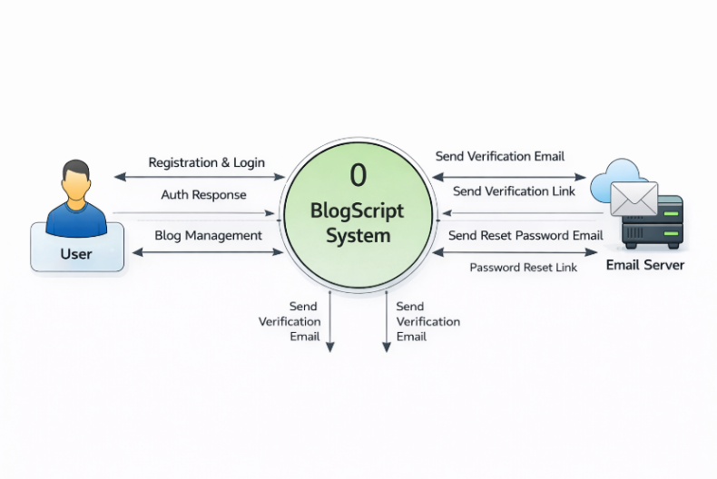
  - Context Diagram

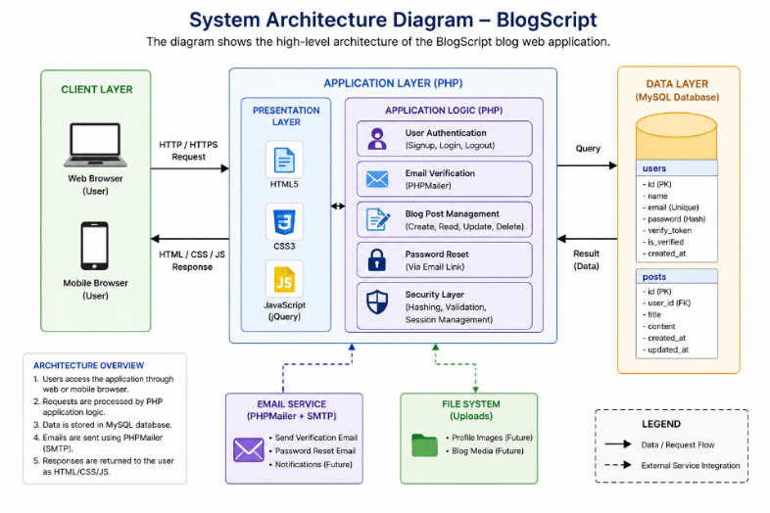
  - System Architecture

Methodology
Step 1: Requirement Analysis
- Identified core features: user authentication, blog post management, and email verification.
- Finalized technology stack: PHP, MySQL, HTML, CSS, JavaScript, PHPMailer.
Step 2: System Design
- Designed the database schema with users and posts tables.
- Designed responsive frontend layouts for signup, login, dashboard, and post pages.
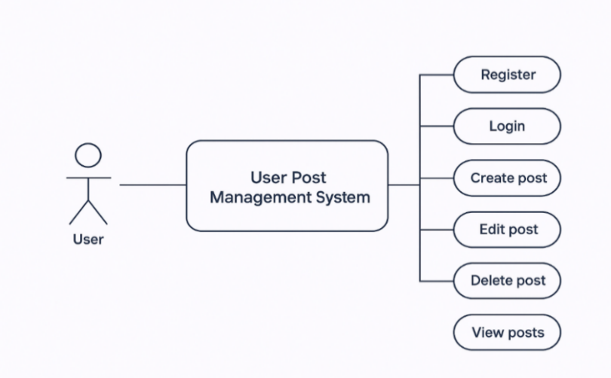

Step 3: Backend Development
- Implemented User Authentication (signup, login, password hashing).
- Added Email Verification using PHPMailer.
- Developed CRUD operations for posts (create, read, update, delete).
- Implemented password reset functionality with email link.
Step 4: Frontend Development
- Built responsive UI using HTML, CSS (custom + media queries), and JavaScript.
- Integrated forms for login, signup, post creation, and update.
Step 5: Integration
- Integrated database queries with prepared statements for security.
- Linked PHPMailer for sending verification and reset emails.
Step 6: Testing
- Conducted unit testing for individual modules.
- Performed integration testing for login, signup, and post management.
- Tested the platform on different devices for responsive design.
Step 7: Deployment & Future Scope
- Deployed the project on local XAMPP server for testing.
- hosted on a live server with domain and SSL for real-world use.
- Future scope includes adding admin dashboard, comments, and SEO optimization.

Technologies to be use

6.1 Software Platform
- Frontend Technologies
- HTML5 - For creating the structure and layout of web pages.
- CSS3 - For styling, responsiveness, and UI design.
- JavaScript (jQuery) - For client-side validation, interactivity, and DOM manipulation.
- Backend Technologies
- PHP (Core PHP) - For server-side scripting, handling requests, implementing business logic, and integrating with the database.
- PHPMailer - For sending verification and password reset emails using SMTP.
- Database
- MySQL - To store and manage user accounts, authentication data, and blog posts.
- Users table (for user details, passwords, verification codes)
- posts table (for blog posts created by users)
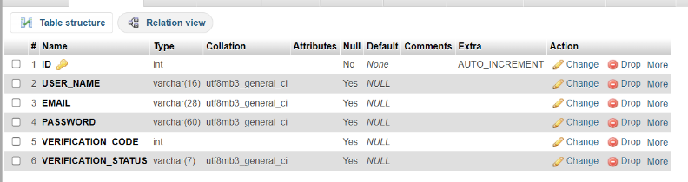

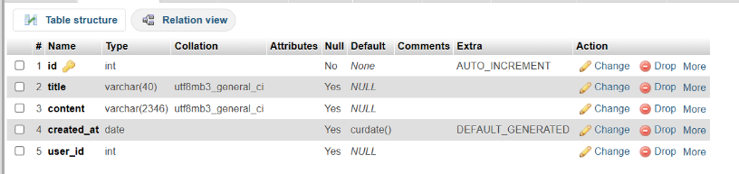

- Server Environment
- XAMPP (Apache, MySQL, PHP, Perl) - Used as the local development environment.
- Apache Server - To host and run the PHP application locally.
- Development Tools
- VS Code - Code editor for writing and debugging code.
- phpMyAdmin - For managing MySQL databases.
- Git/GitHub (optional) - For version control and project collaboration.
- Other Supporting Tools
- Google Fonts (Poppins) - For better typography.
- Browser Developer Tools - For testing responsiveness and debugging frontend issues.
- Hosting Server
- Infinity free - For free hosting and testing server with SSL certificate and sub domain.
6.2 Hardware Platform : RAM, Hard Disk , OS, Editor etc

Advantages of this Project

Simple and User-Friendly Interface
The platform is designed with simplicity in mind, allowing users to navigate easily without any technical difficulty. The clean layout ensures that users can focus on writing and managing their blogs rather than learning complex features. This makes the application suitable for beginners as well as experienced users.
- Secure Authentication System
BlogScript provides a secure login and signup system using password hashing techniques, which protects user credentials from unauthorized access. The password reset feature further enhances security by allowing users to safely recover their accounts without compromising data integrity.
- Email Verification for Account Authenticity
The inclusion of email verification ensures that only genuine users can create accounts. This helps prevent fake registrations, reduces spam, and increases the overall trustworthiness of the platform.
- Responsive Design
BlogScript is built with a responsive design that adapts smoothly to both desktop and mobile devices. This ensures a consistent user experience across different screen sizes and allows users to access and manage their blogs anytime and anywhere.
- Practical for Real-World Blogging Needs
The project addresses real-world blogging requirements such as security, content control, and ease of use. Its practical features make it suitable for personal blogging, educational use, or small-scale content platforms.

- Customizable and Scalable
The system is designed to be easily customizable. Additional features such as comments, likes, categories, and SEO tools can be integrated in the future. This makes the project scalable and adaptable to different user
- Complete Blog Management with CRUD Operations
The application supports all essential CRUD operations (Create, Read, Update, Delete), allowing users full control over their blog content. Authors can publish new posts, update existing ones, and remove content whenever required, ensuring flexibility and efficient content management.

Assumptions, if any
The project assumes that users have basic internet access and fundamental knowledge of using web applications. It is also assumed that users will provide valid email addresses for account verification and password recovery. The system is designed for small to medium-scale usage, where server resources and network connectivity remain stable.

Future Scope and further enhancement of the Project
The current version of the project provides a strong foundation for a modern blogging platform. However, with the rapid growth of digital content creation and user expectations, there are several opportunities to enhance the system further. These future enhancements can significantly improve user engagement, scalability, performance, and overall usability. The following points describe the possible future scope and improvements that can be implemented in the project.
- Comments and Likes System
One of the most important future enhancements is the implementation of a Comments and Likes System. This feature will allow readers to actively interact with blog posts by sharing their opinions, feedback, and suggestions.
A comments system encourages healthy discussions between readers and authors, making the platform more interactive and community-driven. Users will be able to post comments, reply to other comments, and engage in meaningful conversations. Moderation features can also be added to prevent spam and abusive content.
The likes system will enable readers to express appreciation for posts they enjoy. This feature not only boosts author motivation but also helps identify popular content. Additionally, likes data can be used to rank posts, display trending blogs, and improve content recommendations.
- Rich Text Editor
Currently, content creation may be limited to plain text. A Rich Text Editor can greatly enhance the content writing experience for authors. This editor will allow users to format text using bold, italics, headings, lists, and block quotes.
Authors will also be able to add images, embed videos, insert links, and include multimedia elements directly into their blog posts. This makes the content visually appealing and more engaging for readers. Popular editors like TinyMCE, CKEditor, or Quill can be integrated for this purpose.
A rich text editor improves content quality, professionalism, and readability, making the platform suitable for serious bloggers and content creators
- SEO Optimization
Search Engine Optimization (SEO) is a crucial factor for any blogging platform. Future enhancements can include SEO-friendly features to improve the visibility of blog posts on search engines like Google.
- Custom meta titles and descriptions
- SEO-friendly URLs
- Keyword optimization
- Sitemap generation
- Faster page loading speeds
By implementing SEO optimization, blog posts can rank higher in search results, leading to increased traffic and better reach. This enhancement will benefit both content creators and platform administrators by increasing platform popularity.

Project Repository Location
S# | Project Artifacts | Location | Verified By Project Guide
01 | Code | https://github.com/Pankajdas0025/BlogScript-website-
02 | Live | https://blogscriptapp.free.nf/
03 | Database | localhost / localhost:3306 / blog | phpMyAdmin 5.2.1
04 | Report | https://github.com/Pankajdas0025/BlogScript-website-
05 | Synopsis | https://github.com/Pankajdas0025/BlogScript-website-
06 | Presentation | https://github.com/Pankajdas0025/BlogScript-website-

Definition , Acronyms, and Abbreviations
• CRUD (Create, Read, Update, Delete):
Refers to the four fundamental operations used to manage data in a database. These operations allow users to create new records, retrieve existing data, modify stored information, and delete unwanted records efficiently.

• PHP (Hypertext Preprocessor):
A widely used open-source server-side scripting language designed for web development. It is embedded within HTML and is responsible for handling backend logic, processing user requests, managing sessions, and interacting with databases.

• MySQL:
An open-source relational database management system (RDBMS) used to store and manage structured data. It uses Structured Query Language (SQL) to perform operations like inserting, updating, deleting, and retrieving data efficiently.

• SMTP (Simple Mail Transfer Protocol):
A communication protocol used for sending emails over the internet. In this project, SMTP is used through PHPMailer to send verification emails and password reset links securely.

• UI (User Interface):
Refers to the visual components of the application that users interact with, such as buttons, forms, layouts, and navigation elements. A good UI ensures ease of use and accessibility.

• UX (User Experience):
Represents the overall experience of users while interacting with the application. It includes usability, responsiveness, performance, and satisfaction level of the user.

• ERD (Entity Relationship Diagram):
A visual representation of the database structure that shows entities (tables), their attributes (fields), and relationships between them. It helps in designing and understanding database architecture.

• DFD (Data Flow Diagram):
Illustrates how data moves through the system, including input, processing, storage, and output. It helps in understanding system functionality and data processing steps.

• API (Application Programming Interface):
A set of rules that allows different software components to communicate with each other. It enables interaction between frontend and backend systems.

• HTTP/HTTPS (HyperText Transfer Protocol / Secure):
Protocols used for communication between client (browser) and server. HTTPS ensures secure data transmission using encryption.

• Session:
A mechanism used to store user data temporarily on the server to maintain user state (e.g., login status) across multiple pages.

• Cookie:
A small piece of data stored on the user's browser to remember user preferences and session information.

• Hashing:
A security technique used to convert passwords into encrypted formats, making them unreadable and protecting user data from unauthorized access.

• SQL Injection:
A type of cyber attack where malicious SQL queries are inserted into input fields. It is prevented using prepared statements and input validation.

• Responsive Design:
A web design approach that ensures the application works smoothly across different devices like mobiles, tablets, and desktops.

• Frontend:
The client-side part of the application that users directly interact with, built using HTML, CSS, and JavaScript.

• Backend:
The server-side part of the application responsible for processing logic, database interaction, and handling user requests.

Conclusion
The BlogScript project successfully demonstrates the design and implementation of a CRUD-based blog web application that addresses the essential needs of modern content creators. By providing a clean and intuitive interface, the system allows users to register securely, authenticate their accounts, and manage blog posts efficiently through create, read, update, and delete operations. The inclusion of email verification and password reset functionality strengthens account security and enhances user trust in the platform.
Beyond its core functionality, the project highlights the importance of building a system that balances simplicity with performance. Many existing blogging platforms often overwhelm users with complex features and unnecessary distractions. In contrast, BlogScript focuses on delivering a minimal and user-friendly environment where users can concentrate on content creation without interruptions. This approach makes the application especially useful for beginners, students, and independent creators who prefer a lightweight and easy-to-use blogging solution.
From a technical perspective, the project reflects a strong understanding of full-stack web development. The integration of frontend technologies such as HTML, CSS, and JavaScript with backend technologies like PHP and MySQL ensures a smooth flow of data between the user interface and the database. The use of structured database design, including proper relationships between users and posts, ensures data consistency and reliability. Additionally, implementing prepared statements and password hashing techniques enhances the overall security of the application, protecting it from common vulnerabilities such as SQL injection and unauthorized access.
The development process of BlogScript also demonstrates a systematic approach to software engineering. Starting from requirement analysis to system design, development, testing, and deployment, each phase was carefully executed to ensure the successful completion of the project. The use of tools such as XAMPP, phpMyAdmin, and modern code editors helped streamline the development process and improve productivity. Testing across different devices further ensured that the application is responsive and provides a consistent user experience.
Another significant aspect of this project is its scalability and potential for future enhancement. Although the current version provides all essential blogging functionalities, it can be further extended by integrating advanced features such as comment systems, likes and engagement tracking, rich text editors, media uploads, and SEO optimization. These improvements can transform BlogScript from a basic blogging platform into a more comprehensive and competitive web application.
In addition to technical learning, this project has also contributed to the development of problem-solving skills and practical knowledge. It provided hands-on experience in handling real-world challenges such as user authentication, session management, email integration, and database operations. Working on this project has strengthened the understanding of how different components of a web application interact with each other to deliver a complete and functional system.
Overall, BlogScript is a practical and well-structured project that successfully meets its objectives. It not only serves as a functional blogging platform but also acts as a strong foundation for future development and innovation. The knowledge and experience gained through this project can be applied to more advanced systems in the future, making it a valuable learning experience in the field of web development.

References
The following references were used throughout the development and documentation of the BlogScript web application. These sources provided technical guidance, best practices, and conceptual clarity for implementing various features of the system.
a) PHP Documentation Team
Title: PHP Official Documentation
Website: https://www.php.net/docs.php
The official PHP documentation served as the primary source for understanding server-side scripting concepts and backend development. It provided detailed explanations of PHP syntax, built-in functions, and advanced features such as session handling, form processing, and error management. The documentation was especially useful for implementing user authentication, password hashing using password_hash() and password_verify(), and handling secure data transmission between the client and server. It also guided the integration of external libraries and ensured that coding practices followed standard conventions.

b) Oracle Corporation – MySQL Documentation

Title: MySQL Reference Manual
Website: https://dev.mysql.com/doc/
The MySQL official documentation was used to design and manage the relational database for the BlogScript application. It provided comprehensive knowledge about database creation, table structure, indexing, and query optimization. The resource was particularly helpful in implementing CRUD operations (Create, Read, Update, Delete) efficiently. It also supported understanding of relational integrity, foreign keys, and normalization techniques to maintain consistent and structured data. Additionally, it guided the use of secure queries and database performance optimization.

c) GeeksforGeeks

Title: Web Development Tutorials (HTML, CSS, JavaScript, PHP)
Website: https://www.geeksforgeeks.org
GeeksforGeeks was used as a supportive learning platform for understanding both fundamental and advanced web development concepts.

d) World Wide Web Consortium (W3C)

Title: HTML5 Specification
Website: https://www.w3.org/TR/html5/
The W3C HTML5 specification served as a standard reference for structuring web pages according to modern web development practices. It ensured that the application followed proper semantic structure, accessibility standards, and compatibility across different browsers. This resource helped in designing well-structured forms, input elements, and page layouts that are both user-friendly and compliant with global web standards.

e) Mozilla Developer Network (MDN)

Title: MDN Web Docs (HTML, CSS, JavaScript)
Website: https://developer.mozilla.org
MDN Web Docs was one of the most valuable resources for frontend development. It provided in-depth explanations, examples, and best practices for HTML, CSS, and JavaScript. It was extensively used for implementing responsive design using CSS, handling events using JavaScript, and improving overall user interface behavior. The documentation also helped in debugging issues and understanding browser compatibility for different features.

f) GitHub Documentation

Title: GitHub Docs
Website: https://docs.github.com
GitHub documentation was used for understanding version control and project management practices.

g) PHPMailer Documentation

Title: PHPMailer GitHub Repository & Docs
Website: https://github.com/PHPMailer/PHPMailer
PHPMailer documentation was used to implement email functionality in the BlogScript application.

h) phpMyAdmin Documentation

Title: phpMyAdmin Official Documentation
Website: https://www.phpmyadmin.net/docs/
phpMyAdmin was used as a database management tool during development. Its documentation helped in performing database operations such as creating tables, running SQL queries, and managing data visually. It simplified database handling without requiring complex command-line operations.

i) Google Fonts

Title: Google Fonts Library
Website: https://fonts.google.com
Google Fonts was used to enhance the typography of the BlogScript user interface. It provides a wide range of free and web-safe fonts that improve readability and visual appeal. The “Poppins” font was used in the project to create a modern and clean design.

j) Browser Developer Tools (Chrome DevTools)

Title: Chrome Developer Tools Documentation
Website: https://developer.chrome.com/docs/devtools/

14. Appendices
The appendices section provides visual representations and structured details of the BlogScript system. These diagrams and supporting materials help in understanding the internal working, data flow, and user interactions of the application in a clear and simplified manner.
A. Data Flow Diagram (DFD)
The Data Flow Diagram (DFD) illustrates how data moves through the BlogScript system, including input, processing, storage, and output. It provides a high-level overview of how users interact with the system and how the backend processes requests.

In the BlogScript application, the primary external entity is the User, who interacts with the system through actions such as registration, login, creating blog posts, updating content, and deleting posts. When a user submits information (such as login credentials or blog content), the data is sent to the application server where it is processed.

The system validates user input, performs necessary operations (such as authentication or CRUD operations), and communicates with the database to store or retrieve data. The processed data is then returned to the user in the form of web pages or responses.

The DFD typically consists of the following components:

- External Entity: Represents users interacting with the system
- Process: Represents operations such as login validation, post creation, and data processing
- Data Store: Represents the database where user and blog data are stored
- Data Flow: Shows the movement of data between different components

This diagram helps in understanding the logical flow of information and ensures that all processes are correctly connected and functioning as expected.
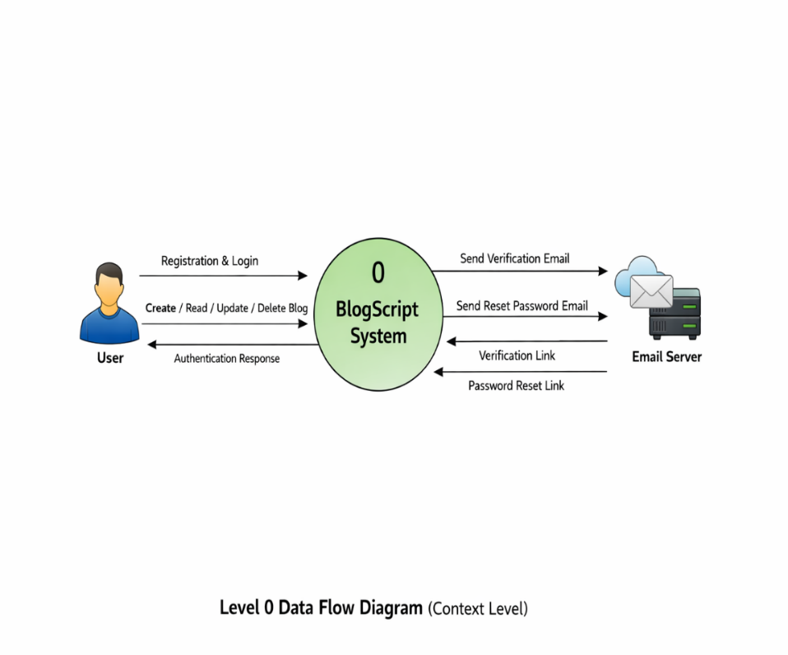

B. Entity Relationship Diagram (ERD)
The Entity Relationship Diagram (ERD) represents the database structure of the BlogScript application. It shows how different entities (tables) are related to each other and how data is organized within the system.
In this project, the main entities include:
- Users Table: Stores user-related information such as user ID, name, email, password (hashed), and verification status
- Posts Table: Stores blog-related information such as post ID, title, content, author ID, and timestamps
The relationship between these entities is defined as one-to-many, where one user can create multiple blog posts, but each blog post belongs to only one user. This relationship is established using a foreign key (user ID) in the posts table.
The ERD helps in:
- Designing a structured and normalized database
- Maintaining data consistency and integrity
- Avoiding redundancy in data storage
- Simplifying database queries and operations
By visualizing the database schema, developers can easily understand how data is connected and ensure efficient data management within the system.
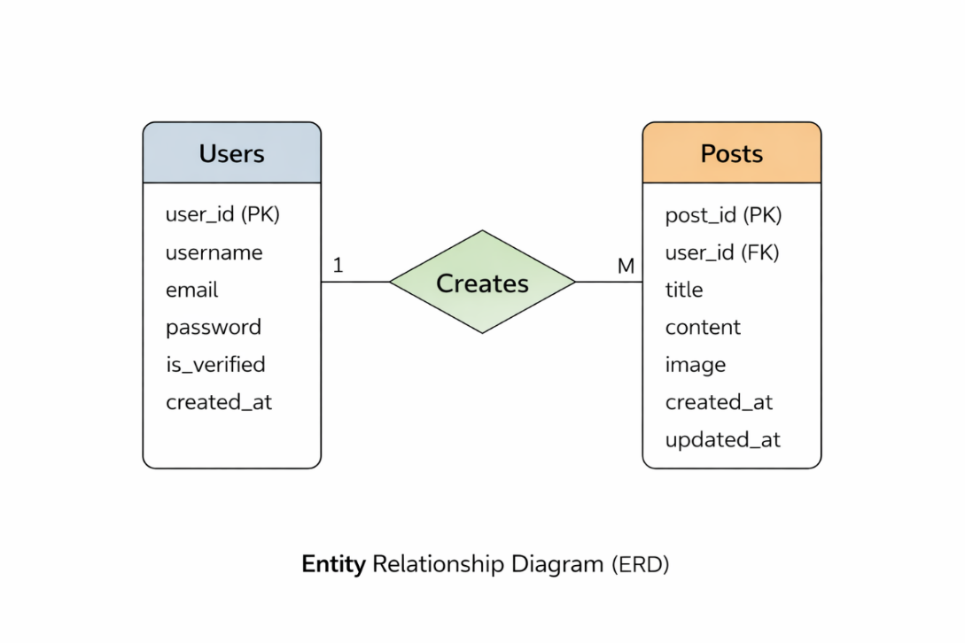

C. Use Case Diagram (UCD)
The Use Case Diagram (UCD) illustrates how users interact with the BlogScript system and the various functionalities available to them. It provides a graphical representation of system behavior from the user's perspective.
The primary actor in this system is the User, who performs multiple actions such as:
- Registering a new account
- Logging into the system
- Creating blog posts
- Viewing blog posts
- Editing existing posts
- Deleting posts
- Logging out of the system
Each of these actions is represented as a use case, showing how the user interacts with different parts of the system. The diagram highlights the relationship between the user and system functionalities, making it easier to understand the overall workflow.
- Identifying system requirements
- Understanding user interactions
- Simplifying system design and communication
- Providing a clear overview for stakeholders and developers
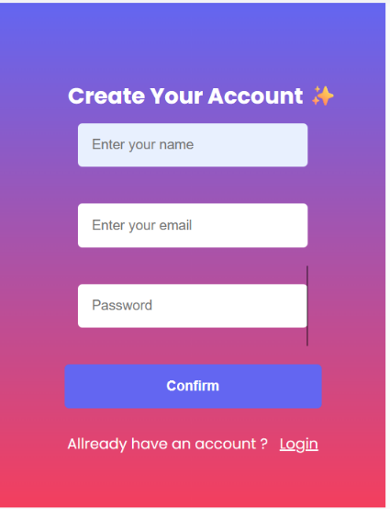
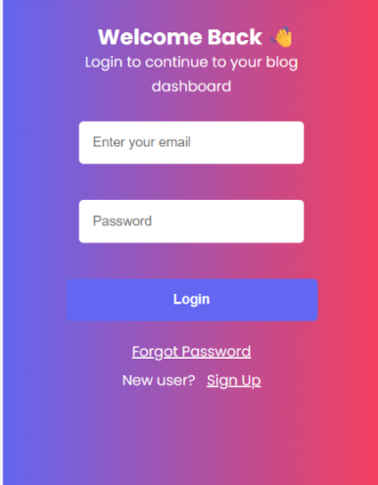
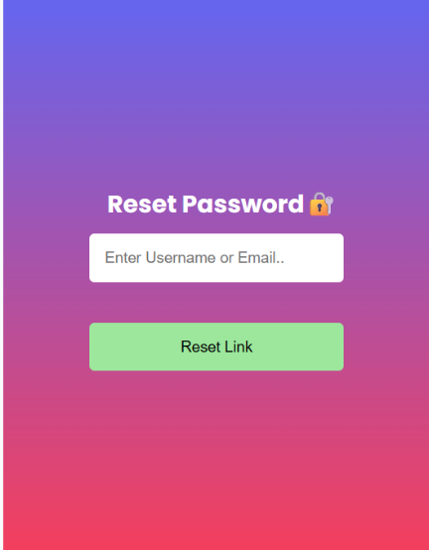

D. Data Dictionary (DD)
The Data Dictionary provides detailed information about the data elements used in the BlogScript application. It defines the structure, type, and purpose of each field in the database tables.
Users Table Fields:
- user_id: Unique identifier for each user
- user_name: Stores the full name of the user
- email: Stores the user’s email address
- password: Stores the hashed password for security
- verification_code: Used for email verification
- verified_status: Indicates whether the user is verified
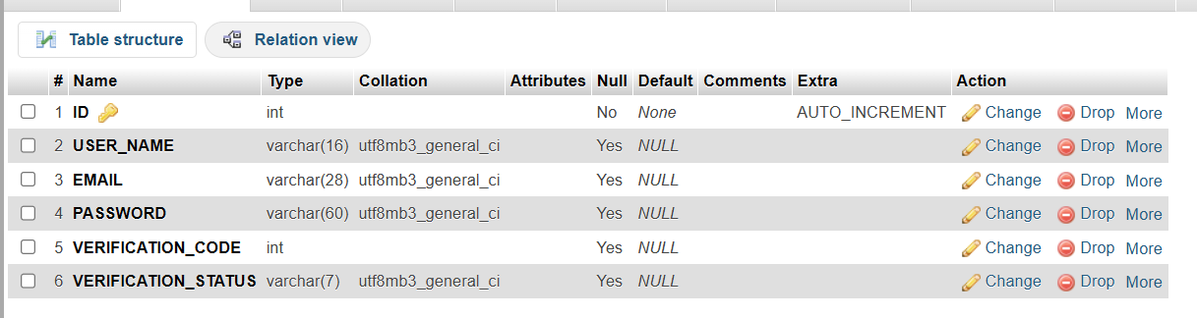

Posts Table Fields:
- post_id: Unique identifier for each blog post
- user_id: Foreign key linking the post to a user
- title: Title of the blog post
- content: Main content/body of the post
- created_at: Timestamp of post creation
The data dictionary helps developers understand the structure of the database and ensures consistency in data usage throughout the application.
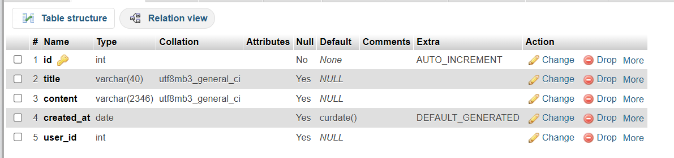

Admin Table Fields:
- id: Unique identifier for each admin
- username: Stores the full name of the admin
- password_hash: Stores the hashed password for security
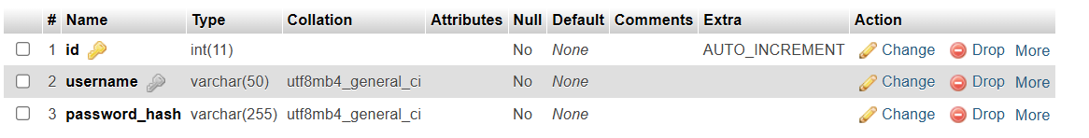

Blog Likes Table Fields:
- id: Unique identifier for each record
- blog_id: Refers to the blog post id
- user_id: Refers to the user who created the post

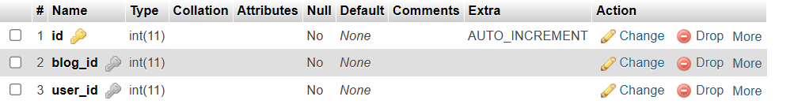

Newsletter SubscribersTable Fields:
- id: Unique identifier for each subscribers
- email: Unique email id for every subscribers
- subscribed_at: Date of subscription

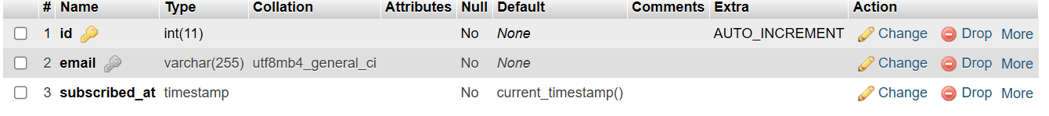

E. Screenshots
Screenshots provide a visual representation of the BlogScript application interface and its functionalities. These images demonstrate how the system works in real-time and give a clear idea of the user experience.
The following screenshots are typically included:
- User Registration Page: Shows the signup form with input fields
- Login Page: Displays the authentication interface
- Dashboard/Home Page: Lists blog posts
- Create Post Page: Interface for writing and publishing blogs
- Edit Post Page: Allows modification of existing posts
- Password Reset Page: Shows email-based reset functionality
Screenshots help in:
- Demonstrating the working of the system
- Improving report presentation
- Providing visual proof of implementation
- Making it easier for evaluators to understand the project

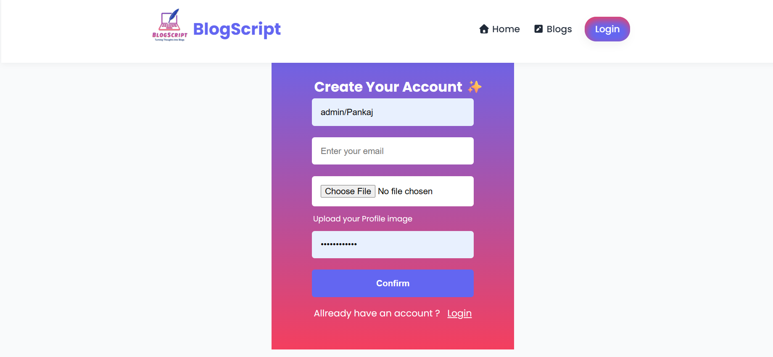

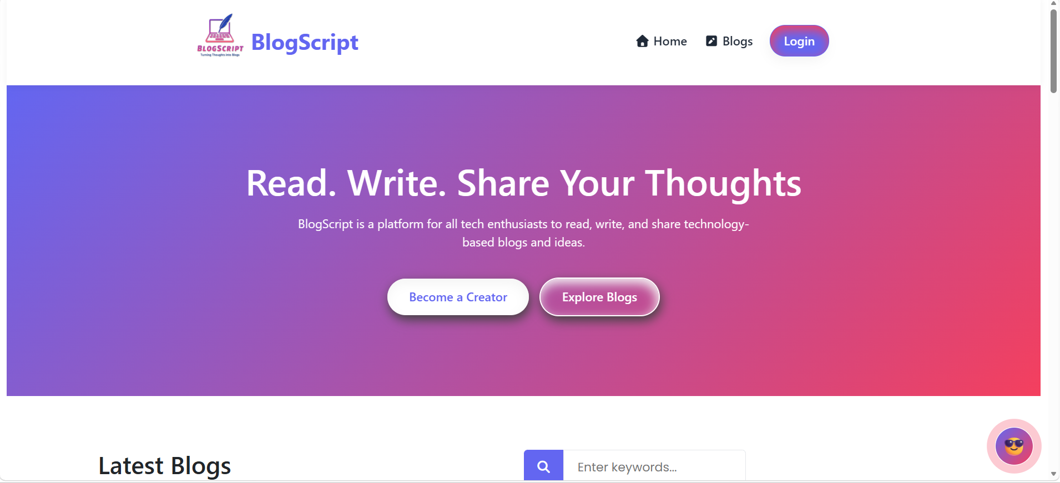

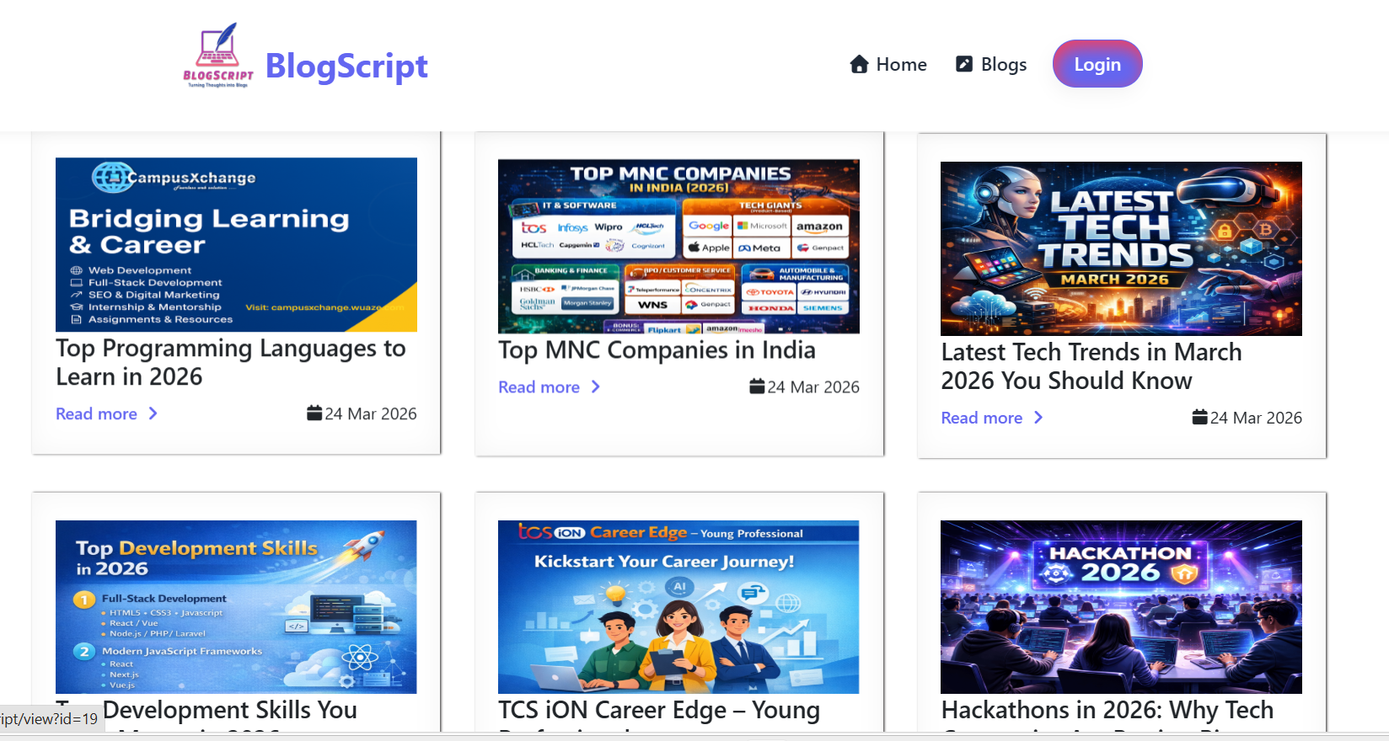

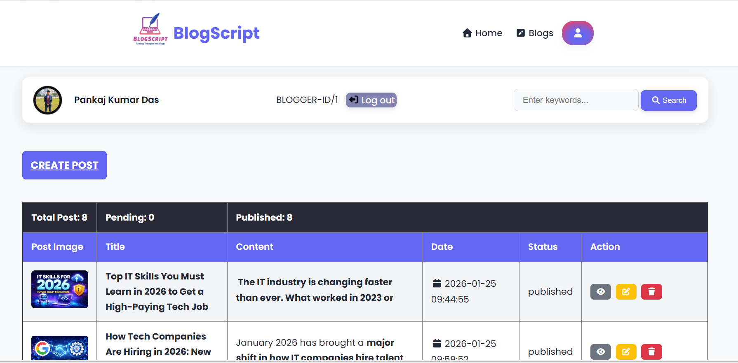

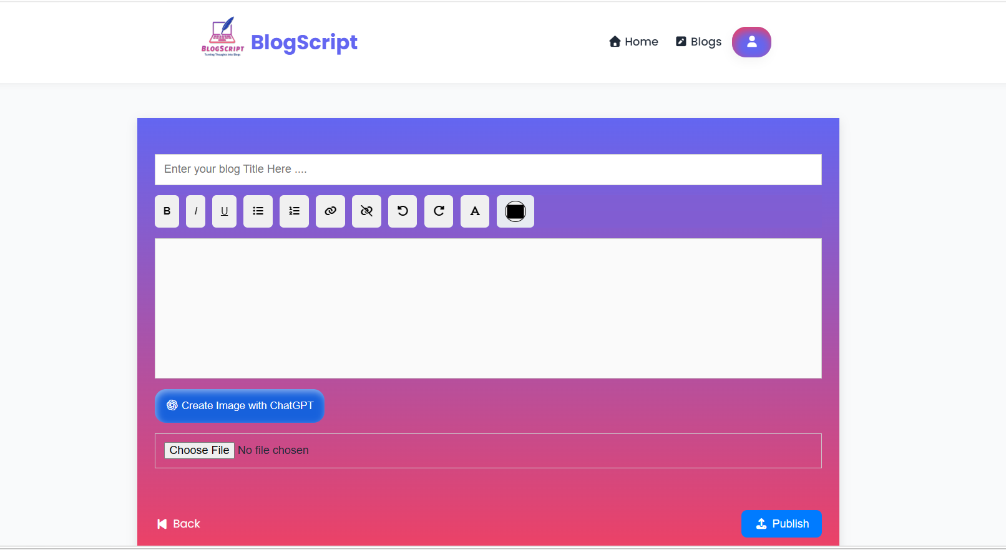
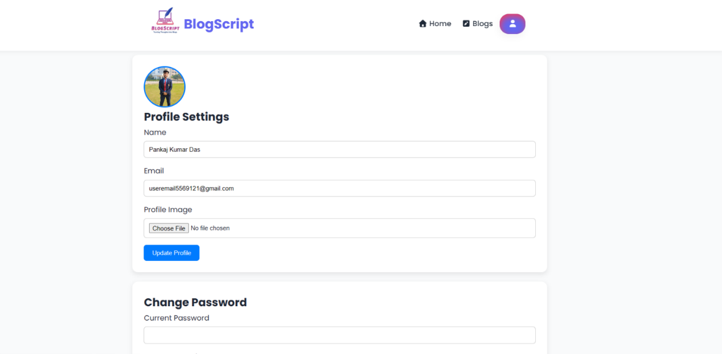

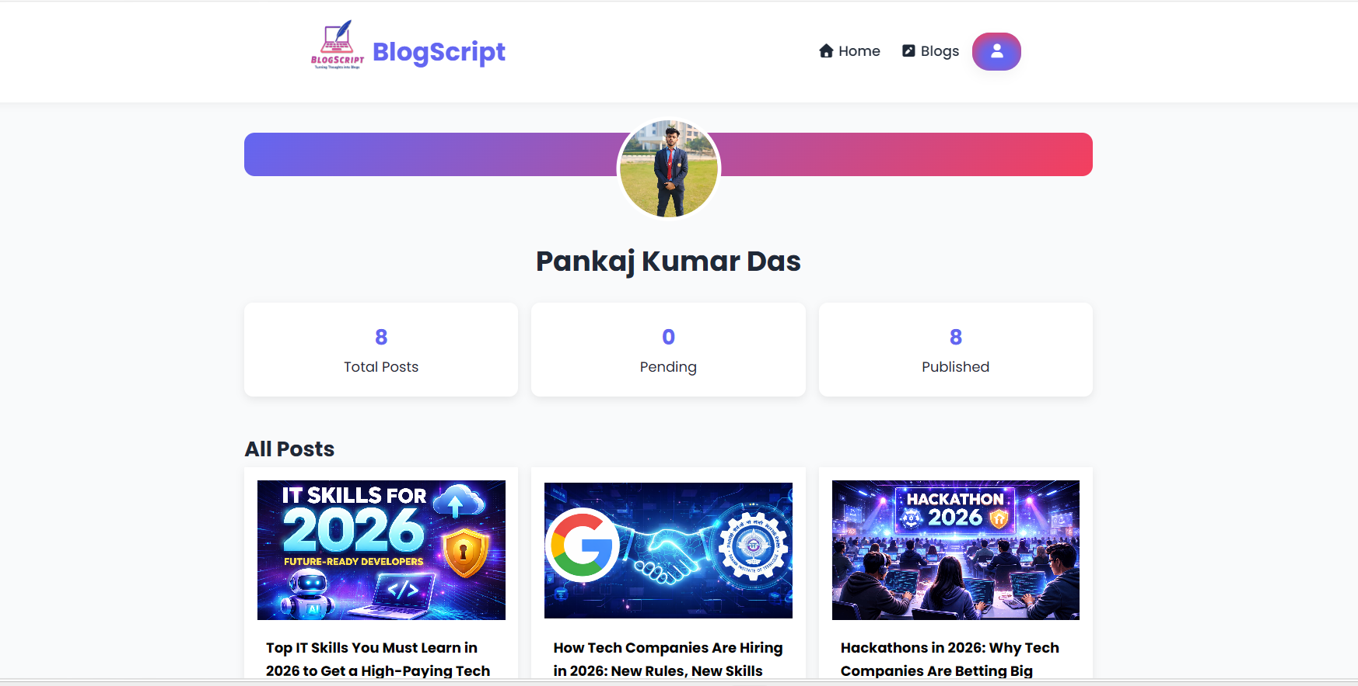

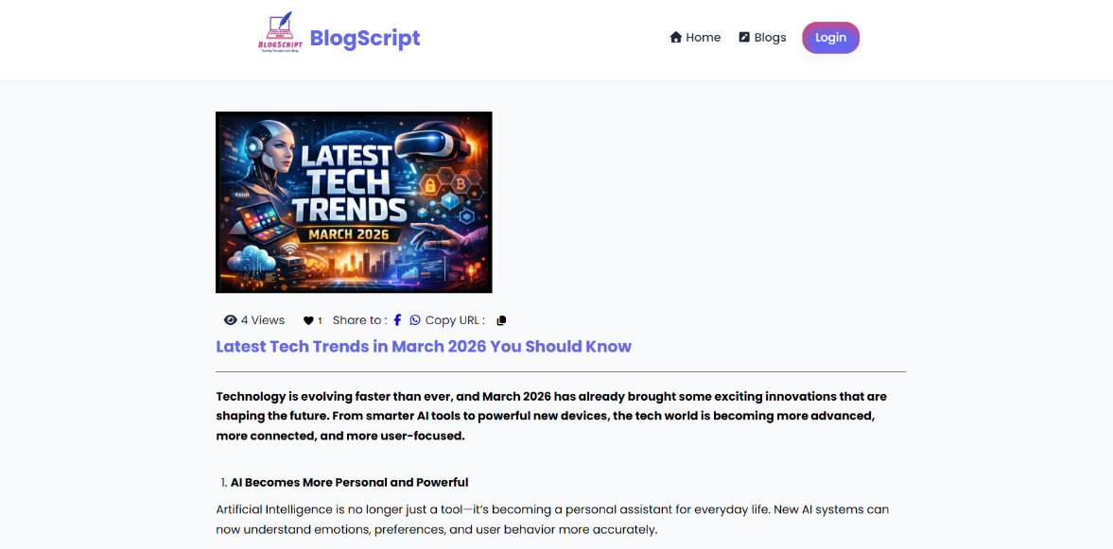

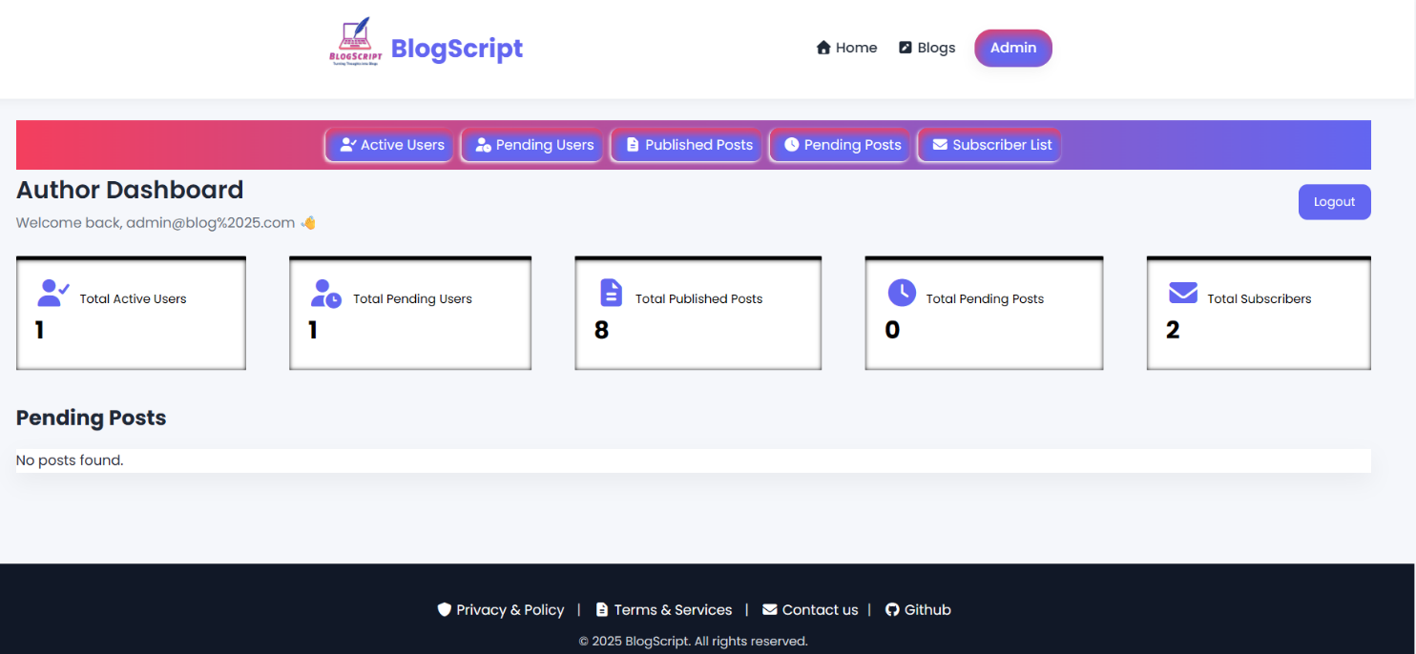

F. Project Repository
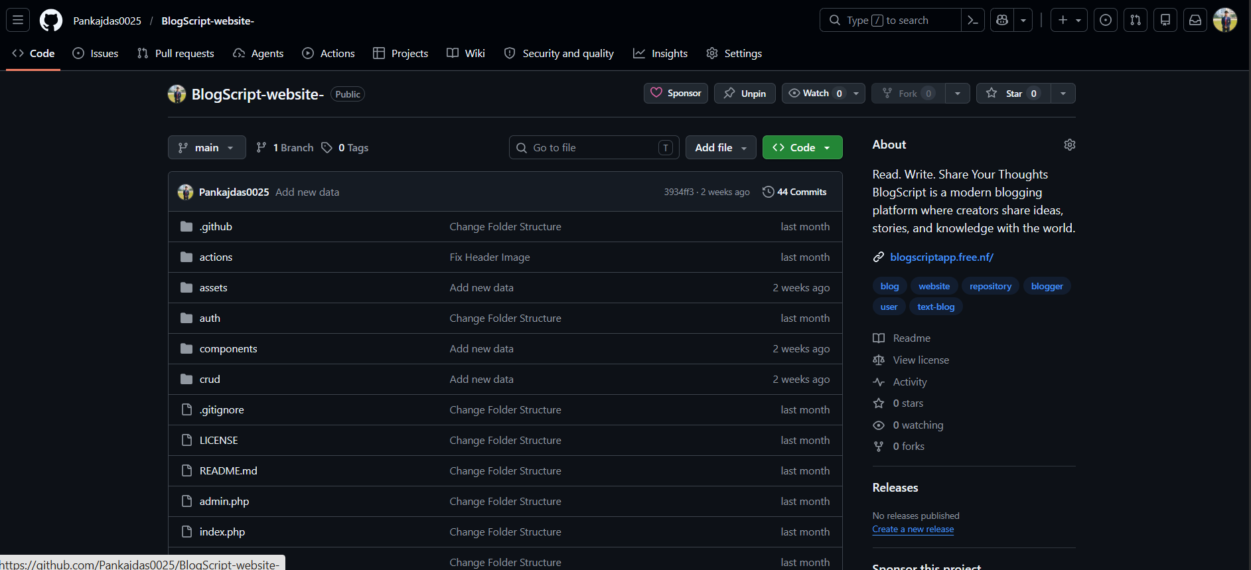

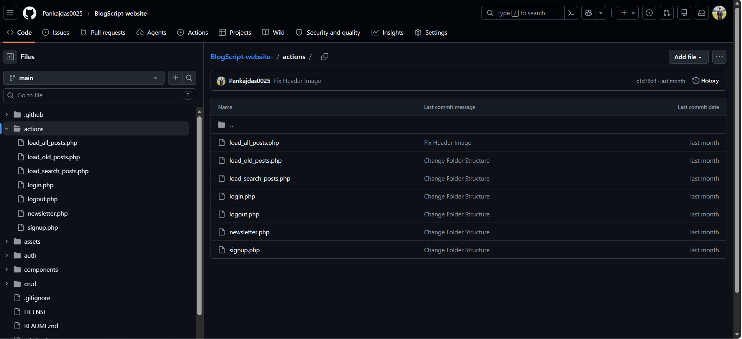

15. Acknowledgement
We would like to express our sincere gratitude to all those who have contributed directly or indirectly to the successful completion of this project titled “BlogScript Blog Web Application.” This project has been a valuable learning experience, and its successful execution would not have been possible without the support, guidance, and encouragement of many individuals.
First and foremost, we extend our heartfelt thanks to our respected project guide, Mr. Ajay Singh, for his continuous guidance, valuable suggestions, and constant encouragement throughout the development of this project. His expertise and insights helped us understand the practical aspects of web development and guided us in overcoming various challenges during the implementation phase. His timely feedback and support played a crucial role in improving the quality and structure of our work.
We are also deeply thankful to the faculty members of the College of Computing Science & Information Technology, Teerthanker Mahaveer University, Moradabad, for providing us with the necessary academic knowledge, technical skills, and supportive environment required to complete this project successfully. The theoretical concepts and practical exposure provided during the course of our study greatly contributed to the development of this application.
We would like to acknowledge the role of various online resources, documentation platforms, and learning websites that helped us understand complex concepts and implement them effectively. These resources acted as a constant support system during the development process and enhanced our technical knowledge.
We are equally grateful to our friends and classmates for their valuable suggestions, constructive feedback, and technical discussions, which helped us refine our ideas and improve the overall implementation of the project. Their cooperation and encouragement made the development process more productive and engaging.
We would also like to express our sincere appreciation to our team members for their coordination, dedication, and teamwork. The successful completion of this project was made possible through effective collaboration, shared responsibilities, and mutual support among all members of the team.
Finally, we express our deepest gratitude to our family members for their unwavering support, patience, and motivation. Their encouragement and belief in our abilities gave us the confidence to complete this project with dedication and determination.

